# PE3 – Variables and Expressions

1. In the following code, how would we refer to the name great from code in the namespace fabulous?

namespace fabulous

{

// code in fabulous namespace

}

namespace super

{

namespace smashing

{

// great name defined

}

}

1. Which of the following are not legal variable names. Why?

myVariableIsGood 99Flake

iLike#Tags

_floor

rit_tigers

time2GetJiggyWidIt

$bankBalance

Factorial!

MAX_SIZE

black&white

99Flake

Start with number

iLike#Tags

contain #

$bankBalance

Contain and start with $

Factorial!

Contain !

black&white

contain &

1. Is the string "supercalifragilisticexpialidocious" too big to fit in a string variable? Why?

No. string can contain 2GB.

1. By considering operator precedence, list the steps involved in the computation of the following expression:

resultVar += var1 * var2 + var3 % var4 / var5;

var1*var2

var3%var4

var3%var4/var5

var1*var2+var3%var4/var5

resultVar = resultVar+ var1*var2+var3%var4/var5

1. Write a console application that obtains four int values from the user and displays the product. Hint: you may recall that the Convert.ToDouble() command was used to covert the input from the console to a double; the equivalent command to convert from a string to an int is Convert.ToInt32().

Enter the URL for your GitHub project here:

Complete

https://github.com/whisperers26/IGME206---Homework.git

1. *Define the following terms.*

compiler:

identifier:

primitive data type:

class:

constant:

parsing:

compiler: tool to translate high-level language into machine language

identifier: symbol to name the entities

primitive data type: the basic data type to build a complicated data type, or the data type defined by language

class: a block to represent an object and its behaviours and attributes

constant: a value that cannot be edited along all the execution

parsing: divide commands (programs) into small pieces and check correct syntax.

1. *Evaluate the following expressions using the C# order of precedence.*
2. 19 % 5 Result:
3. 13 / 4 Result:
4. 100 % 20 – 10 Result:
5. 5 + 7 * 2 – 2 Result:
6. (6 / 4.0 + 3.5) / 2 Result:
7. 4
8. 3
9. -10
10. 17
11. 2.5
12. What are the values for num1, num2, and num3 after the following code is executed? (Hint: Pay attention to data types.)

int num1 = 2;

int num2 = 4;

int num3 = 5;

num1 = num1 * num3;

num2 = num1 / num2;

num3 = num3 % num2;

The final value of num1 =10

The final value of num2 =2

The final value of num3 =1

1. The following line of code doesn’t compile:

int amountOfMoney = "3.50";

a. What is wrong with the code?

String cannot be assigned to a int

b. What is one way you could fix it, and why would you fix it that way?

double amountOfMoney = Convert.ToDouble(“3.50”)

this variable is to record the money, so it should be precise

1. Which of the following are *not* *smartly* *named* C# variable identifiers? Why?

a. qb

b. totalValue

c. theNextValueInTheList

d. player1Score

a Because it makes no sense

c. its too long and too hard to read

1. Categorize each of the following errors as either: compile-time error, run-time error, or logical error.

a. Multiplying 2 numbers when you meant to add them

b. Dividing by zero

c. Forgetting a semicolon at the end of a programming statement

d. Spelling a word wrong in the output

e. Producing inaccurate results

f. Typing a { when you should have typed (

1. Logical
2. Run-time
3. Compile-time
4. Logical
5. Logical
6. Compile-time
7. What is the output produced by the following code statements. Indicate escape sequences (ie. special characters), if there are any.

Console.Write("Hi there");

Console.Write("David");

Hi thereDavid

There are no escape sequences

1. What is the output produced by the following code statement? Indicate escape sequences (ie. special characters), if there are any.

Console.Out.WriteLine("50 plus 25 is " + 50 + 25);

50 plus 25 is 5025\n

1. Write the 3 lines of code needed to produce the following output in a console window. (Hint: The underline on the second line is a blinking cursor waiting for your input.)

Please type your name below.

**_**

Your name is !

Press any key to continue . . .

Please type your name below.

Cookie

Your name is Cookie!

Press any key to continue . . .

Console.WriteLine("Please type your name below.");

string name = Console.ReadLine();

Console.WriteLine($"Your name is {name}!");

1. Write the C# line of code that creates a string with the identifier *myName* that holds your first name.

*string myName = “David”;*

1. Now, add your last name to the string using string concatenation.

*myName += “ Liu”;*

1. Consider these strings:

string englishNo = "No";

string spanishNo = "no";

Does C# find the strings englishNo and spanishNo to be equivalent? If not, why?

They are not equivalent. N and n corresponds to different values in ASCII.

1. My program asks the user for input by using Console.ReadLine(). Complete the lines of code to parse the input to a double, then add 55.0 to the number and print the result to the console.

Console.WriteLine("Please enter a number with a decimal precision of 2.");

string input = Console.ReadLine();

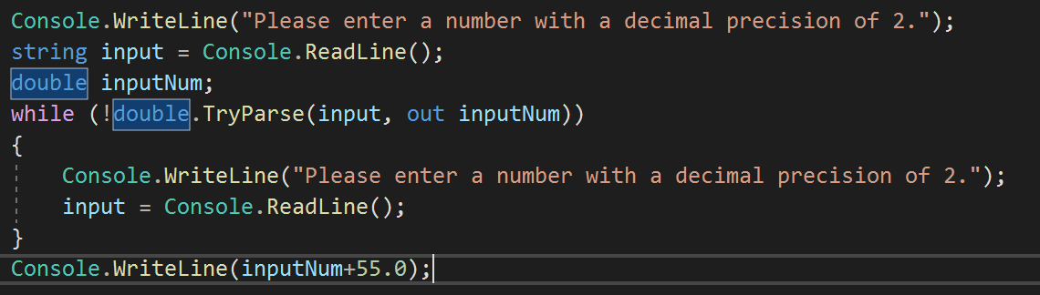

The best way is to define a bool ifSuccess as false at first and put the first two lines into the loop, so it looks more clear. But in this question, we are just required to add lines, so it’s just fine. Anyway, it still works.

1. A program reads input from a user into a string *userInput*. Which of the following lines of code properly parses *userInput* into an integer *userNumber*?

string userInput = Console.ReadLine();

a. int userNumber = int.ParseInt(userInput);

b. int userNumber = int.Parse(userInput);

c. int userInput = Parse(userNumber);

d. int userInput = int.Parse(userNumber);

b

1. *True or false?*

**T F** Comments negatively affect a program’s processing and compilation and facilitate human comprehension.

**T F** Appropriate white space makes a program harder to read.

**T F** A class is a blueprint of an object. Multiple objects can be created from one class definition.

**T F** C# is also known as Db.

fftt

## Submission

Upload this document to the corresponding MyCourses dropbox.

Add, Commit and Push the project for #5 to your GitHub repository.